Office of the Phone 207- 853- 2300
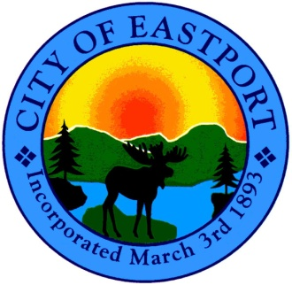
City Manager and FAX 207- 853- 4712
the City Council

CITY COUNCIL MEETING
Wednesday, February 8th, 2012
6:00 P.M. - SHEAD HIGH SCHOOL

Public Hearings

● Liquor License Renewal - Leslie & Jeffrey Starling
d/b/a The Happy Crab

● Public Facilities Grant/Public Safety Facility
Fire Station (County Road)

● Public Infrastructure Grant
Renovation & Upgrade - Sewage Treatment Plant (County Road)

Regular Monthly Council Meeting

- - Call to Order

- - Adjustments to Agenda

- - Action on Public Hearings

- - Minutes of Previous Meetings
● 1/11/2012

- - Department Reports
● Financial Report - Code Enforcement Report & Assessor Reports
● Police Department Report - Public Works Report - Sewer Report

- - Boards and Committees - Reports & Appointments
● Planning Board - ZBA - Historic Review Board
● Airport - Harbor - Marine Resource - Cemetery - Recycling
● Downtown - Eastport for Pride
● Port Report

- - Updates
● Ambulance
● Marion Transfer

- - Schedule Public Hearings and/or Workshops

● Public Hearing for 3/8/12 – Community Enterprise Grant ($150,000)
Façade Program for the Downtown Historic District

- - Formation of Committee (Re: Deep Cove Road Boat Ramp)

- - Appointment of Committee (Re: Deep Cove Road Boat Ramp)
● George “Butch” Harris - Fisherman
● Charlie Leppin - Harbor Master/Tug Captain
● Chris Bartlett - Marine Biologist for the State
● Thomas Critchley - Federal Marine
● Scott Emery - Councilor/Fisherman
● Paul Thompson - Grant Writer
● Earl Small - Former Councilor/Fisherman

- - Tax Acquired Mobile Home Located at 24 Mitchell Street

- - CITY MANAGER’S ISSUES
● City’s Municipal Membership with WCCOG – FY2012
(Washington County Council of Governments)

- - OPEN FORUM (Will be held at 8:00 p.m. when meetings extend beyond)

- - EXECUTIVE SESSION

- - ADJOURNMENT

